Bandit Level 10 → Level 11
Level Goal:
The password for the next level is stored in the file data.txt, which contains base64 encoded data
Commands you may need to solve this level:
grep, sort, uniq, strings, base64, tr, tar, gzip, bzip2, xxd
Solution:
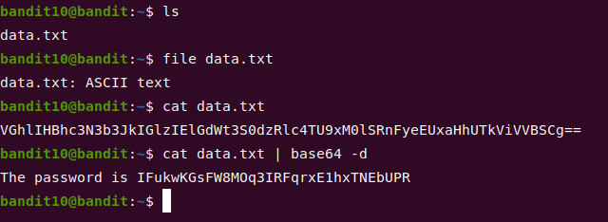
Bandit Level 11 → Level 12
Level Goal:
The password for the next level is stored in the file data.txt, where all lowercase (a-z) and uppercase (A-Z) letters have been rotated by 13 positions
Commands you may need to solve this level:
grep, sort, uniq, strings, base64, tr, tar, gzip, bzip2, xxd
Solution:
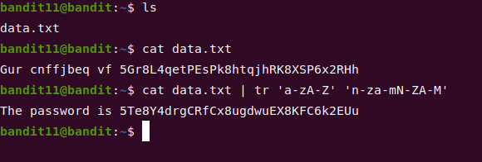
Bandit Level 12 → Level 13 🤨
Level Goal:
The password for the next level is stored in the file data.txt, which is a hexdump of a file that has been repeatedly compressed. For this level it may be useful to create a directory under /tmp in which you can work using mkdir. For example: mkdir /tmp/myname123. Then copy the datafile using cp, and rename it using mv (read the manpages!)
Commands you may need to solve this level:
grep, sort, uniq, strings, base64, tr, tar, gzip, bzip2, xxd, mkdir, cp, mv, file
Solution:
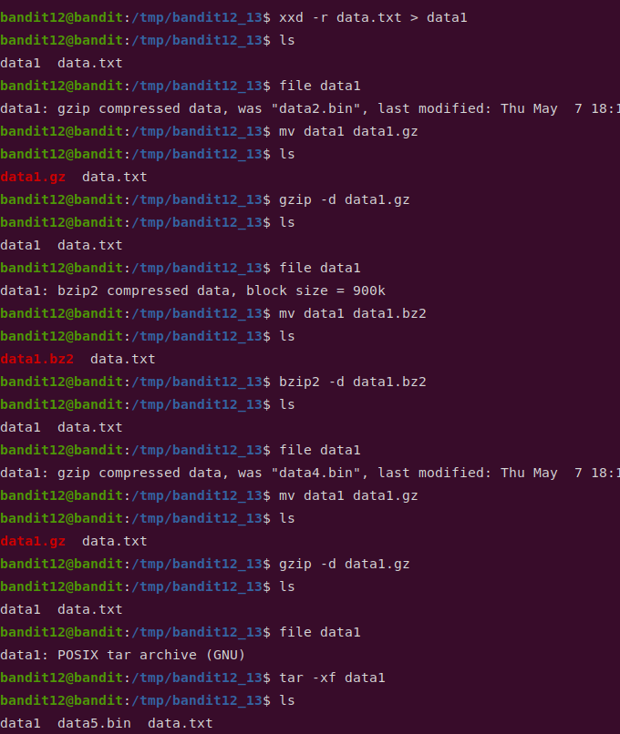
repeat compression and changing file extension until file gives ASCII as output like below:
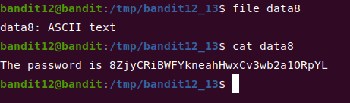
Bandit Level 13 → Level 14
Level Goal:
The password for the next level is stored in /etc/bandit_pass/bandit14 and can only be read by user bandit14. For this level, you don’t get the next password, but you get a private SSH key that can be used to log into the next level. Note: localhost is a hostname that refers to the machine you are working on
Commands you may need to solve this level:
ssh, telnet, nc, openssl, s_client, nmap
Solution:
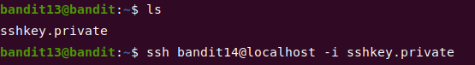
You will be logged in as user bandit14
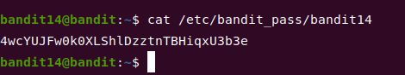
Bandit Level 14 → Level 15
Level Goal:
The password for the next level can be retrieved by submitting the password of the current level to port 30000 on localhost.
Commands you may need to solve this level:
ssh, telnet, nc, openssl, s_client, nmap

Solution:
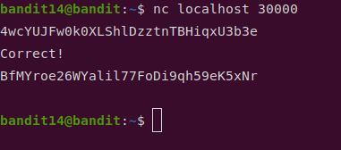
Bandit Level 15 → Level 16
Level Goal:
The password for the next level can be retrieved by submitting the password of the current level to port 30001 on localhost using SSL encryption.
Helpful note: Getting “HEARTBEATING” and “Read R BLOCK”? Use -ign_eof and read the “CONNECTED COMMANDS” section in the manpage. Next to ‘R’ and ‘Q’, the ‘B’ command also works in this version of that command…
Commands you may need to solve this level:
ssh, telnet, nc, openssl, s_client, nmap
Solution:
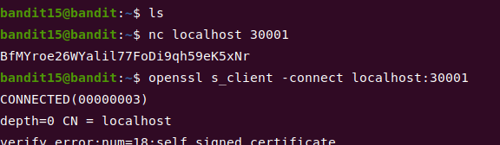
Scroll down and paste in bandit15’s password:
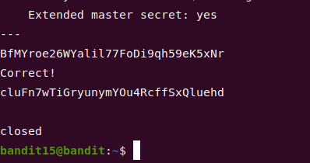
Bandit Level 16 → Level 17
Level Goal:
The credentials for the next level can be retrieved by submitting the password of the current level to a port on localhost in the range 31000 to 32000. First find out which of these ports have a server listening on them. Then find out which of those speak SSL and which don’t. There is only 1 server that will give the next credentials, the others will simply send back to you whatever you send to it.
Commands you may need to solve this level:
ssh, telnet, nc, openssl, s_client, nmap
Solution:
- nmap -sV = port scan and determine the name of found services and their version.
- -p 31000–32000 = port range from 31000 to 32000
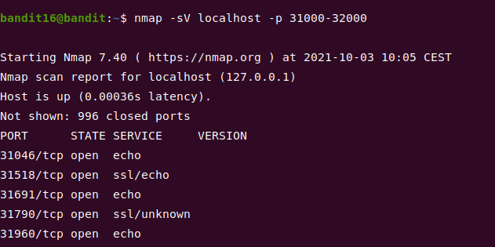
- Connect to service on port 31790 using openssl command like previous level
- Once connected, paste in bandit16’s password
- You’ll get an SSH private key:
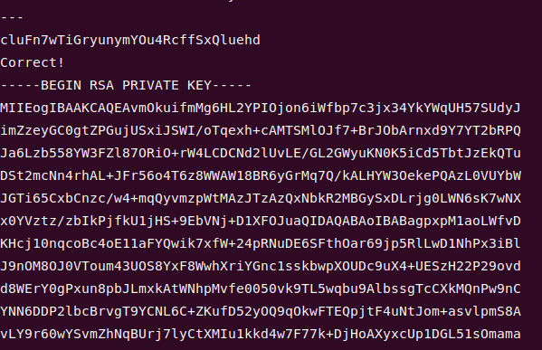
- Create a temporary folder using mkdir command
- Create a file using nano command and paste the private key in it
- Change the privatekey file permission to read only to avoid too open error when connect to bandit17 using SSH:
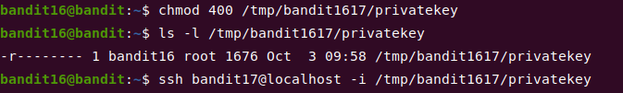
- Once logged in as bandit17, cat the password
- Answer is : xLYVMN9WE5zQ5vHacb0sZEVqbrp7nBTn
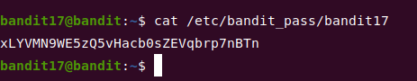
Bandit Level 17 → Level 18
Level Goal:
There are 2 files in the homedirectory: passwords.old and passwords.new. The password for the next level is in passwords.new and is the only line that has been changed between passwords.old and passwords.new
NOTE: if you have solved this level and see ‘Byebye!’ when trying to log into bandit18, this is related to the next level, bandit19
Commands you may need to solve this level:
cat, grep, ls, diff
Solution:
Can you guess which one is the answer?
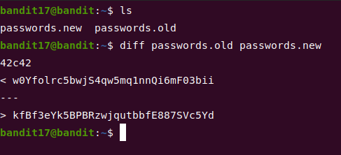
Bandit Level 18 → Level 19
Level Goal:
The password for the next level is stored in a file readme in the homedirectory. Unfortunately, someone has modified .bashrc to log you out when you log in with SSH.
Commands you may need to solve this level:
ssh, ls, cat
Solution:
- run: ssh bandit18@bandit.labs.overthewire.org -p 2220 ls
- You will get a readme file and kicked out right away:
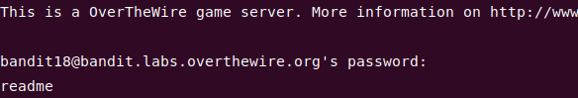
- run: ssh bandit18@bandit.labs.overthewire.org -p 2220 cat readme
- You will get the password.
Bandit Level 19 → Level 20
Level Goal:
To gain access to the next level, you should use the setuid binary in the homedirectory. Execute it without arguments to find out how to use it. The password for this level can be found in the usual place (/etc/bandit_pass), after you have used the setuid binary.
Solution:
- Execute the given binary file in order to become bandit20 user and read the password:
